# FitSphere

A PROJECT REPORT

for

Mini Project-I (K24MCA18P) Session (2024-25)

Submitted by

Yashvi Chaudhary – 2426MCA2207 Tushar Prajapati – 2426MCA218 Tanisha Jain – 2426MCA713

Submitted in partial fulfilment of the requirements for the degree of

# MASTER OF COMPUTER APPLICATION

Under the supervision of Ms. Divya Singhal Assistant Professor



Submitted to

DEPARTMENT OF COMPUTER APPLICATIONS KIET GROUP OF INSTITUTIONS, GHAZIABAD

UTTAR PRADESH-201206 (DECEMBER- 2024)

# CERTIFICATE

Certified that **Tushar-Kumar(2426MCA218), Yashvi-Chaudhary(2426MCA2207), Tanisha- Jain(2426MCA713)** have carried out the project work having “**FitSphere Health Website**” (**Mini Project-I, K24MCA18P**) for **Master of Computer Application** from Dr. A.P.J. Abdul Kalam Technical University (AKTU**)** (formerly UPTU), Lucknow under my supervision. The project report embodies original work, and studies are carried out by the students themselves and the contents of the project report do not form the basis for the award of any other degree to the candidate or to anybody else from this or any other University/Institution.

**Ms. Divya Singhal Dr. Arun Kr. Tripathi**

**Assistant Professor Dean**

**Department of Computer Applications Department of Computer Applications**

**KIET Group of Institutions, Ghaziabad KIET Group of Institutions, Ghaziabad**

# FitSphere

Yashvi Chaudhary – 2426MCA2207 Tushar Prajapati – 2426MCA218 Tanisha Jain – 2426MCA713

# ABSTRACT

FitSphere is a comprehensive digital platform designed to promote health and wellness through personalized fitness plans, nutritional guidance, and motivational resources. The platform addresses the growing need for accessible and adaptable health solutions for individuals seeking to achieve a balanced lifestyle. FitSphere features a range of tools, including BMI calculators, expert-curated diet plans, workout routines, and yoga guides. These features cater to both beginners and seasoned fitness enthusiasts. The platform emphasizes intermittent fasting as a sustainable approach to weight management and provides well-researched meal plans and guidelines to support this lifestyle. With its user-friendly interface and robust functionality, FitSphere allows users to track progress, access tailored recommendations, and stay motivated through community engagement. By integrating cutting-edge technology with fitness expertise, the platform ensures a seamless experience for users aiming to improve their physical and mental well-being. Additionally, FitSphere promotes holistic health by focusing on balanced nutrition, hydration, and mental clarity through activities such as yoga and mindfulness. It empowers users to make informed decisions and adopt habits that lead to long-term health benefits. The project demonstrates an innovative approach to addressing modern health challenges by providing an accessible, scalable, and sustainable solution. FitSphere aspires to be a trusted companion in every user's journey towards a healthier, stronger, and more balanced life.

**Keywords:** Health, Fitness, Nutrition, Intermittent Fasting, BMI

# ACKNOWLEDGEMENT

Success in life is never attained single-handedly. My deepest gratitude goes to my project supervisor, Ms. Divya Singhal for her guidance, help, and encouragement throughout my project work. Their enlightening ideas, comments, and suggestions.

Words are not enough to express my gratitude to Dr. Arun Kumar Tripathi, Professor and Dean, Department of Computer Applications, for his insightful comments and administrative help on various occasions.

Fortunately, I have many understanding friends, who have helped me a lot on many critical conditions.

Finally, my sincere thanks go to my family members and all those who have directly and indirectly provided me with moral support and other kind of help. Without their support, completion of this work would not have been possible in time. They keep my life filled with enjoyment and happiness.

Tushar Kumar Yashvi Chaudhary Tanisha Jain

# TABLE OF CONTENTS

1. Introduction 1-6
   1. The Modern Lifestyle and Its Challenges 1-3
      1. The Shift Towards a Sedentary Lifestyle
      2. The Impact of Unhealthy Dietary Habits
      3. Mental Health Challenges in the Digital Age
      4. The Need for Innovative Wellness Solutions
   2. Overview of FitSphere 3-4
      1. Bridging the Gap Between Technology and Wellness
      2. FitSphere’s Core Philosophy
   3. Key Features of FitSphere 4-5
      1. Personalization Through Technology
      2. Holistic Wellness
      3. Focus on Sustainable Health Practices
   4. Unique Selling Points of FitSphere 5
      1. Accessibility for All Fitness Levels
      2. Evidence-Based Recommendations
      3. Integration of Mental and Physical Health
   5. The Promise of FitSphere 6
2. Feasibility Study 7-12
   1. Technical Feasibility 7-8
      1. Technology Stack
      2. AI and Machine Learning
      3. Resource Availability
   2. Economic Feasibility
      1. Cost Analysis
      2. Revenue Streams
      3. Market Demand
   3. Operational Feasibility 9-10
      1. User-Centric Features
      2. Organizational Readiness
      3. Scalability
   4. Legal Feasibility 10-11
      1. Data Protection
      2. Licensing and Agreements
      3. Liability and Disclaimers
   5. Scheduling Feasibility 11-12
      1. Project Timeline
      2. Resource Allocation
3. Project Objective 13-18
   1. Providing Tailored Fitness Solutions for Diverse Users 13-14
      1. Personalized Fitness Plans
      2. Dynamic Adjustments to Goals
   2. Promoting Sustainable Dietary Practices 14
      1. Simplifying Intermittent Fasting
      2. Personalized Meal Plans
   3. Enhancing Mental and Emotional Well-Being 15
      1. Integration of Yoga and Mindfulness
      2. Promoting Emotional Balance
   4. Leveraging Technology for Real-Time Health Tracking 15-16
      1. BMI Calculators and Activity Trackers
      2. Real-Time Feedback
   5. Fostering a Supportive and Collaborative Community 16-17
      1. Peer Support and Shared Goals
      2. Expert Guidance
   6. Addressing Barriers to Fitness and Wellness Accessibility 17-18
      1. Simplifying the User Experience
      2. Catering to Diverse Demographics
   7. Creating a Scalable and Adaptable Platform 18
      1. Incorporating Emerging Technologies
      2. Continuous Updates and Improvements
4. Hardware and Software Requirements 19-20
   1. Hardware Requirements
      1. For development
      2. For end users
   2. Software Requirements
      1. Development Tools
      2. Deployment
      3. End User Software Requirements
5. Project Flow 21-24
   1. Project Flow
   2. Research Methodology
6. Project/Research Outcome 25-28

References/ Bibliography

# CHAPTER - 1 INTRODUCTION

In today's fast-paced and technology-driven world, maintaining a healthy lifestyle has become increasingly challenging. The demands of work, personal commitments, and social obligations often take precedence, leaving little room for physical activity or mindful eating. Compounding the issue is the widespread availability of processed foods and the stress associated with modern life.

Amidst these challenges, FitSphere emerges as a comprehensive solution to bridge the gap between technological convenience and wellness. By integrating modern tools with a focus on holistic health, FitSphere empowers individuals to take control of their well-being in a sustainable manner. This section explores the multifaceted nature of FitSphere, beginning with the challenges posed by modern lifestyles and leading into its core philosophy and innovative features.

## The Modern Lifestyle and Its Challenges

The modern lifestyle has redefined human activity, often at the expense of health and wellness. While technological advancements have improved convenience and productivity, they have also introduced unintended consequences. This section discusses how these shifts have impacted physical and mental health.

## The Shift Towards a Sedentary Lifestyle

The rise of desk jobs, online work environments, and entertainment streaming has significantly reduced physical movement in daily routines. The World Health Organization (WHO) identifies physical inactivity as one of the leading risk factors for global mortality.

* + - * **Reduced Physical Activity**: Jobs now often require sitting for prolonged hours, contributing to poor posture and musculoskeletal disorders.
      * **Overreliance on Technology**: From remote work to on-demand services, technology has replaced many activities that previously required physical effort.
      * **Health Consequences**: A sedentary lifestyle has been linked to obesity, cardiovascular diseases, and diabetes.

Addressing these issues requires structured interventions that fit seamlessly into modern routines—an area where FitSphere excels.

## The Impact of Unhealthy Dietary Habits

The widespread availability of fast food and processed meals has drastically altered dietary patterns. While these options are convenient, they are often high in calories, fats, and sugars, leading to poor nutrition and related health issues.

* + - * **Convenience Over Nutrition**: Processed foods are appealing for their ease of preparation but lack the nutrients needed for optimal health.
      * **Irregular Eating Patterns**: Skipping meals, late-night snacking, and emotional eating have become common behaviors.
      * **Rising Health Issues**: Poor dietary choices contribute to obesity, hypertension, and gastrointestinal disorders.

FitSphere tackles these challenges by providing personalized, research-backed dietary plans and intermittent fasting schedules to guide users toward healthier eating habits.

## Mental Health Challenges in the Digital Age

The digital era has introduced a range of mental health stressors, from information overload to social media pressures.

* + - * **Chronic Stress**: The constant pressure to be productive and available can lead to burnout.
      * **Social Media Influence**: Comparing oneself to curated lifestyles online often results in anxiety and low self-esteem.
      * **Mental Health Disorders**: Stress, anxiety, and depression have become prevalent among individuals of all age groups.
      * Recognizing the interconnectedness of mental and physical health, FitSphere incorporates

mindfulness and yoga practices to promote mental clarity and emotional stability.

## The Need for Innovative Wellness Solutions

Traditional fitness solutions often fail to address the complexity of modern health challenges. Generic exercise routines and one-size-fits-all diets do not account for individual needs or constraints.

* + - * **Barriers to Fitness**: Lack of time, motivation, and knowledge are significant obstacles.
      * **Demand for Personalization**: People seek solutions tailored to their specific requirements, such as fitness level, age, and health conditions.

FitSphere provides an innovative platform that addresses these gaps through technology-driven, user-centric wellness solutions.

## Overview of FitSphere

FitSphere is not just another fitness application; it is a lifestyle transformation platform designed to meet the evolving needs of modern users. This section provides an overview of its purpose and core philosophy.

## Bridging the Gap Between Technology and Wellness

FitSphere leverages advancements in technology to deliver customized wellness experiences. Its intuitive interface ensures accessibility for users across all fitness levels.

* + - * **Data-Driven Approach**: Tools like BMI calculators and activity trackers provide insights into users' health parameters.
      * **Seamless Integration**: The platform connects physical activity, nutrition, and mental well- being into a cohesive framework.

By combining user-friendly design with robust functionality, FitSphere simplifies the process of adopting healthier habits.

## FitSphere’s Core Philosophy

At the heart of FitSphere is the belief that wellness should be inclusive and sustainable.

* + - * **Inclusivity**: The platform caters to diverse demographics, from beginners to seasoned fitness enthusiasts.
      * **Sustainability**: Emphasis on habits that users can maintain long-term rather than short- term fixes.

This philosophy ensures that FitSphere is not only effective but also empowering for its users.

## Key Features of FitSphere

FitSphere offers a wide range of features designed to provide a holistic approach to wellness. These include personalized fitness plans, sustainable dietary guidance, and mental health resources.

## Personalization Through Technology

Personalization is a cornerstone of FitSphere. The platform uses advanced tools to create tailored recommendations based on user input.

* + - * **Health Assessments**: BMI calculators and health surveys help identify individual needs.
      * **Customized Plans**: Exercise routines and diet plans are tailored to each user's goals and preferences.

This ensures that users receive relevant and actionable guidance.

## Holistic Wellness

FitSphere recognizes that true wellness goes beyond physical fitness.

* + - * **Yoga and Mindfulness**: Integrating practices that enhance mental clarity and reduce stress.
      * **Balanced Approach**: Addressing emotional well-being alongside physical health.

## Focus on Sustainable Health Practices

The platform emphasizes practices that users can incorporate into their daily lives with ease.

* + - * **Intermittent Fasting**: Evidence-based meal schedules for effective weight management.
      * **Dietary Simplicity**: Easy-to-follow meal guides that prioritize nutrition and practicality.

## Unique Selling Points of FitSphere

FitSphere distinguishes itself through its accessibility, evidence-based recommendations, and holistic integration.

## Accessibility for All Fitness Levels

FitSphere ensures that its tools and resources are user-friendly for individuals at all stages of their fitness journey.

* + - * **Beginner-Friendly**: Simple and intuitive interface for those new to wellness.
      * **Advanced Tools**: Comprehensive options for experienced users.

## Evidence-Based Recommendations

All of FitSphere's features are grounded in scientific research.

* + - * **Validated Methods**: Diet plans and exercise routines are backed by credible studies.
      * **Reliable Results**: Users can trust the platform for effective and safe guidance.

## Integration of Mental and Physical Health

FitSphere’s unique approach combines physical fitness with mental well-being.

* + - * **Mind-Body Connection**: Yoga and mindfulness complement traditional fitness routines.
      * **Stress Management**: Tools to improve focus and reduce anxiety.

## The Promise of FitSphere

FitSphere aspires to be more than just a fitness application. It aims to be a trusted companion in

every user’s wellness journey, providing tools and support to achieve a healthier, more fulfilling

life. By addressing the pillars of physical health, mental clarity, and nutritional balance, FitSphere empowers individuals to make lasting lifestyle changes.

# CHAPTER - 2 FEASIBILITY STUDY

A feasibility study is an essential component in the planning phase of any project, assessing whether the project is viable, achievable, and beneficial to stakeholders. This section evaluates the technical, economic, operational, legal, and schedule feasibility of the FitSphere Health Website, a comprehensive health and fitness platform designed to empower individuals in their wellness journey.

## Technical Feasibility

Technical feasibility determines whether the technical requirements of the project can be met with the available resources and technologies.

## Technology Stack

The FitSphere Health Website will leverage modern web development technologies to create a robust, scalable, and user-friendly platform:

* + - * Frontend Technologies: HTML5, CSS3, JavaScript, and frameworks like React.js or Angular will ensure a responsive, dynamic, and visually appealing interface.
      * Cloud Hosting: AWS, Azure, or Google Cloud will provide a scalable and secure cloud infrastructure to handle high traffic and real-time operations.
      * Third-Party Integrations: APIs will integrate features like wearable device data syncing (e.g., Fitbit, Garmin), payment gateways (e.g., PayPal, Stripe), and health data (calorie tracking or nutritional databases).

## AI and Machine Learning

The platform will utilize AI/ML algorithms to provide personalized recommendations for workout routines, diet plans, and progress tracking. These technologies will analyze user data (e.g., BMI,

goals, and activity levels) to deliver insights tailored to individual fitness journeys.

## Resource Availability

The required technical expertise for the FitSphere project is accessible:

* + - * Skilled developers, UI/UX designers, and AI specialists are readily available in the market.
      * Open-source libraries and frameworks will reduce development time and costs.

Conclusion:

With the availability of advanced technologies and skilled personnel, FitSphere’s development is technically feasible.

## Economic Feasibility

Economic feasibility evaluates the financial viability of the project, assessing whether the benefits outweigh the costs involved.

## Cost Analysis

The primary cost components include:

1. Development Costs: Salaries for developers, designers, and project managers.
2. Infrastructure Costs: Expenses related to cloud hosting, APIs, and third-party integrations.
3. Marketing Costs: Costs for social media campaigns, SEO optimization, and partnerships with influencers.
4. Maintenance Costs: Post-launch costs, including bug fixes, updates, and server scaling.

## Revenue Streams

FitSphere has multiple potential revenue streams:

1. Subscription Plans: Offer monthly/annual plans for premium features, such as advanced

progress tracking, AI-driven recommendations, and expert consultations.

1. Advertisements: Collaborate with health brands for targeted ads.
2. Partnerships: Collaborate with gyms, fitness equipment companies, and nutrition brands for cross-promotions.
3. One-Time Purchases: Sell fitness-related content like detailed eBooks or specialized meal plans.

## Market Demand

The global digital fitness market is growing significantly, with millions of users seeking health solutions online. FitSphere is well-positioned to tap into this demand with its integrated approach to fitness and wellness.

.

## Operational Feasibility

Operational feasibility assesses the practicality of the project, focusing on its ability to meet user needs and organizational goals.

## User-Centric Features

FitSphere caters to a diverse audience, including:

1. Fitness Enthusiasts: Advanced features like workout tracking, wearable device integration, and fitness challenges.
2. Beginners: Simplified tools such as BMI calculators, basic workout plans, and nutritional guidance.
3. Holistic Health Seekers: Yoga and mindfulness features cater to users interested in mental well-being.

## Organizational Readiness

* + - * The project team has the necessary skills and experience to design, develop, and deploy

the platform effectively.

* + - * Processes for onboarding users, handling customer queries, and managing system updates are in place.

## Scalability

The platform’s modular design ensures scalability, allowing for the integration of new features as user needs evolve. For instance, future updates could include multilingual support, AI- powered virtual trainers, and expanded community-building tools.

## Legal Feasibility

Legal feasibility ensures compliance with regulatory frameworks and addresses potential legal issues.

## Data Protection

User data security is a critical concern. FitSphere will comply with major regulations such as:

* + - * GDPR (General Data Protection Regulation): Ensuring user data privacy for European customers.
      * HIPAA (Health Insurance Portability and Accountability Act): Protecting sensitive health data for U.S. users.

## Licensing and Agreements

* + - * Proper licensing will be obtained for third-party tools, APIs, and copyrighted content used on the platform.
      * Partner agreements with health experts and fitness brands will ensure transparency and mutual benefit.

## Liability and Disclaimers

Clear disclaimers will outline the limitations of health recommendations provided by the platform, emphasizing that it is not a substitute for professional medical advice.

## Scheduling Feasibility

Scheduling feasibility evaluates the project’s timeline to determine whether it is realistic and achievable.

## Project Timeline

The project is planned to be completed in the following phases:

1. Requirement Analysis and Design (1 month): Collect user requirements, create wireframes, and finalize the technology stack.
2. Development (3 months): Build the frontend, backend, database, and integrate APIs.
3. Testing (2 months): Conduct functional, usability, security, and performance testing.
4. Launch and Maintenance (Ongoing): Deploy the platform and address feedback from early adopters.

## Resource Allocation

A dedicated team of developers, designers, and testers ensures adherence to the timeline. Agile methodology will be used to track progress and address challenges.

## Final Recommendation

The feasibility study concludes that the FitSphere Health Website is viable across all dimensions:

* + - * Technical Feasibility: Advanced tools and expertise are available to develop the platform.
      * Economic Feasibility: The revenue potential outweighs the development and operational costs.
      * Operational Feasibility: The platform aligns with user needs and market trends.
      * Legal Feasibility: Compliance with regulations ensures a legally sound platform.
      * Scheduling Feasibility: The timeline is realistic and achievable with adequate resource

allocation.

# CHAPTER - 3 PROJECT OBJECTIVE

The **FitSphere** project aims to redefine health and wellness through an innovative, digital-first approach. By addressing the challenges of modern lifestyles, FitSphere offers a platform that integrates fitness, nutrition, and mental well-being into a cohesive, user-centric solution. The primary objective is to create a holistic digital ecosystem that empowers users to take charge of their health, overcome common barriers to wellness, and achieve sustainable lifestyle changes.

This section delves into the detailed objectives that drive the FitSphere project, focusing on how it leverages technology, personalization, and community to achieve its vision.

## Providing Tailored Fitness Solutions for Diverse Users

One of the foundational goals of FitSphere is to deliver fitness solutions that cater to a wide range of users, from beginners to advanced fitness enthusiasts.

## Personalized Fitness Plans

Generic workout routines often fail to address individual needs, leading to low engagement and limited results. FitSphere addresses this by designing personalized workout plans based on user- specific data such as age, gender, BMI, activity level, and fitness goals.

* + - * **Data-Driven Approach**: Using advanced algorithms, FitSphere analyzes user inputs to generate customized plans that align with their physical capabilities and aspirations.
      * **Inclusivity**: Whether users aim to lose weight, gain muscle, or improve endurance, the platform offers tailored recommendations to meet these diverse goals.

## Dynamic Adjustments to Goals

As users progress in their fitness journeys, their needs evolve. FitSphere tracks this progress and

updates fitness plans accordingly, ensuring that the recommendations remain effective and

relevant.

* + - * **Adaptive Workouts**: The platform adjusts routines based on user performance, making the process more engaging and impactful.
      * **Progress Monitoring**: Real-time tracking tools allow users to measure improvements, boosting motivation and adherence.

## Promoting Sustainable Dietary Practices

Nutrition is a cornerstone of health and wellness, yet it is often one of the most misunderstood aspects. FitSphere simplifies dietary strategies by providing evidence-based tools that promote sustainable eating habits.

## Simplifying Intermittent Fasting

Intermittent fasting has gained popularity for its effectiveness in weight management and metabolic health. However, many users struggle to adopt this practice due to a lack of proper guidance.

* + - * **Fasting Schedules**: FitSphere offers scientifically validated fasting plans, tailored to individual lifestyles and needs.
      * **User-Friendly Guidance**: Clear, step-by-step instructions help users understand and implement fasting without feeling overwhelmed.

## Personalized Meal Plans

The platform provides customized meal plans that align with users’ dietary preferences, caloric needs, and health goals.

* + - * **Balanced Nutrition**: Each meal plan emphasizes nutrient-rich foods while avoiding overly restrictive diets that are difficult to maintain.
      * **Flexibility**: Users can modify plans based on their preferences or availability of ingredients, ensuring practicality and adherence.

## Enhancing Mental and Emotional Well-Being

Recognizing the intricate connection between physical health and mental wellness, FitSphere incorporates features that nurture emotional balance and mental clarity.

## Integration of Yoga and Mindfulness

Physical fitness alone does not guarantee well-being; mental health plays an equally vital role. FitSphere addresses this through yoga and mindfulness practices.

* + - * **Stress Reduction**: Guided yoga sessions and meditation techniques help users manage stress effectively.
      * **Mental Clarity**: Regular mindfulness practices improve focus, reduce anxiety, and enhance emotional resilience.

## Promoting Emotional Balance

FitSphere goes beyond fitness by fostering an environment where users can achieve emotional stability.

* + - * **Relaxation Techniques**: Breathing exercises and calming routines are included to help users unwind after a long day.
      * **Holistic Approach**: By addressing both body and mind, the platform ensures comprehensive wellness.

## Leveraging Technology for Real-Time Health Tracking

FitSphere harnesses the power of technology to provide users with actionable insights into their health metrics.

## BMI Calculators and Activity Trackers

By incorporating tools like BMI calculators and step trackers, FitSphere offers users a clear picture of their current health status.

* + - * **Health Assessments**: Users receive detailed feedback on metrics such as weight, BMI, and caloric expenditure.
      * **Progress Visualization**: Graphs and charts display improvements over time, motivating users to stay consistent.

## Real-Time Feedback

The platform’s technology provides instant feedback on activities, ensuring users make informed decisions in their wellness journey.

* + - * **Adjustable Goals**: Real-time data allows users to refine their objectives based on progress.
      * **Enhanced Engagement**: Immediate results and insights create a sense of achievement, encouraging continued participation.

## Fostering a Supportive and Collaborative Community

Social support is a critical factor in achieving long-term wellness goals. FitSphere integrates community-driven features to keep users motivated.

## Peer Support and Shared Goals

FitSphere encourages users to connect with like-minded individuals who share similar fitness objectives.

* + - * **Group Challenges**: Users can participate in challenges that foster a sense of camaraderie and competition.
      * **Progress Sharing**: By sharing milestones, users inspire and motivate one another to stay on track.

## Expert Guidance

In addition to peer support, FitSphere provides access to professional trainers and nutritionists.

* + - * **Expert Resources**: Users can consult with experts for tailored advice and troubleshooting.
      * **Community Forums**: A platform for discussing challenges, tips, and success stories enhances engagement.

## ddressing Barriers to Fitness and Wellness Accessibility

Many individuals face barriers such as lack of time, motivation, or resources, which prevent them from achieving their health goals. FitSphere aims to remove these obstacles.

## Simplifying the User Experience

The platform is designed to be intuitive and easy to navigate, even for users with minimal technical expertise.

* + - * **User-Friendly Interface**: Clear layouts and straightforward menus make the platform accessible to everyone.
      * **On-Demand Resources**: Content is available anytime, allowing users to integrate wellness into their schedules.

## Catering to Diverse Demographics

FitSphere recognizes that users come from varied backgrounds and have unique needs.

* + - * **Cultural Sensitivity**: Diet and exercise recommendations consider cultural preferences and restrictions.
      * **Flexible Options**: Plans are adaptable for users with varying fitness levels and goals.

## Creating a Scalable and Adaptable Platform

To remain relevant in a rapidly evolving industry, FitSphere is built to scale and adapt to new trends.

## Incorporating Emerging Technologies

The platform is designed to integrate advancements such as AI-driven recommendations and wearable devices.

* + - * **AI Personalization**: Artificial intelligence ensures even greater accuracy in tailoring fitness plans.
      * **Wearable Integrations**: Compatibility with devices like smartwatches enhances tracking capabilities.

## Continuous Updates and Improvements

FitSphere evolves based on user feedback and industry developments.

* + - * **Iterative Design**: Regular updates ensure the platform remains user-centric and efficient.
      * **New Features**: Emerging health trends and tools are incorporated to keep the platform innovative.

# CHAPTER - 4

**HARDWARE AND SOFTWARE REQUIREMENTS**

To successfully develop and operate the "FitSphere" platform, the following hardware and software components are essential:

## Hardware Requirements

* + 1. **For Development**
       - **Processor:** Intel Core i5 or AMD Ryzen 5 (or higher)
       - **RAM:** Minimum 8 GB (16 GB recommended)
       - **Storage:** 256 GB SSD (512 GB SSD recommended)
       - **Graphics:** Integrated graphics (dedicated GPU recommended for design tasks)
       - **Peripherals:** High-resolution monitor, keyboard, mouse, and optional external storage

## For End Users

* + - * **Device Types:** Smartphone, tablet, or PC with internet connectivity

## Minimum Requirements:

* + - * + Smartphones/Tablets: Dual-core processor, 2 GB RAM, and modern operating system (Android 8.0+ or iOS 12+)
        + PCs: Dual-core processor, 4 GB RAM, and a modern web browser

## Software Requirements

* + 1. **Development Tools**
       - **Frontend Development:** HTML5, CSS3, JavaScript (Bootstrap for responsive

design)

* + - * **IDE/Code Editor:** Visual Studio Code, Sublime Text, or Notepad++
      * **Graphics and Design Tools:** Adobe Photoshop, Figma, or Canva for creating UI/UX elements and illustrations

## Deployment

* + - * **Web Hosting Service:** Shared or cloud-based hosting services like Hostinger,

Bluehost, or GoDaddy

* + - * **Domain Name:** For platform branding and accessibility

## End-User Software Requirements

* + - * **Web Browsers:** Google Chrome, Mozilla Firefox, Safari, or Microsoft Edge (latest versions recommended)
      * **Mobile Platforms:** Android (8.0 or higher) and iOS (12.0 or higher) for compatibility with the website or progressive web app

# CHAPTER - 5 PROJECT FLOW

The development of the "FitSphere" platform follows a structured methodology, ensuring systematic planning, implementation, and evaluation to meet the project objectives effectively.

## Project Flow

* + 1. **Requirement Analysis**
       - Conduct a detailed analysis of user needs, including fitness goals, dietary preferences, and technical abilities.
       - Identify key features such as BMI calculators, workout plans, intermittent fasting guides, and yoga tutorials.

## Design and Planning

* + - * **UI/UX Design:**
        + Create wireframes and prototypes for an intuitive and visually appealing user interface.
        + Ensure responsiveness across multiple devices (smartphones, tablets, and PCs).

## Content Creation:

* + - * + Develop engaging and informative content for fitness routines, diet plans, and health tips.

## Frontend Development

* + - * Build the platform using HTML5, CSS3, and JavaScript.
      * Implement Bootstrap or similar frameworks for responsiveness and dynamic visuals.
      * Incorporate animations and interactivity for an enhanced user experience.

## Integration of Tools and Features

* + - * Embed BMI calculators for personalized health assessments.
      * Add workout and diet plan modules with structured recommendations.
      * Include interactive yoga guides and mental wellness resources.

## Testing and Quality Assurance

* + - * Conduct usability testing to ensure smooth navigation and functionality.
      * Perform cross-browser and cross-device testing to verify compatibility.
      * Collect user feedback through beta testing and refine the platform accordingly.

## Deployment and Launch

* + - * Deploy the platform on a web hosting service with a user-friendly domain name.
      * Optimize the website for SEO to improve visibility and accessibility.

## Post-Launch Monitoring and Updates

* + - * Monitor user engagement and analyze traffic data to assess platform performance.
      * Regularly update content, improve features, and resolve any technical issues based on user feedback.

## Research Methodology

* + 1. **Data Collection**
       - Conduct surveys and interviews with potential users to understand their fitness and health needs.
       - Review existing literature and successful fitness platforms to identify best practices and trends.

## Feature Validation

Compare proposed features against user feedback and research findings to ensure relevance and usability.

* + - * Validate fitness and diet plans with certified health professionals.

## User-Centric Design

* + - * Adopt an iterative design process, incorporating user feedback at every stage to improve usability and functionality.

## Evaluation Metrics

* + - * Measure success based on user satisfaction, engagement rates, and platform reliability.
      * Use tools like Google Analytics to track performance metrics and gather insights for future improvements.

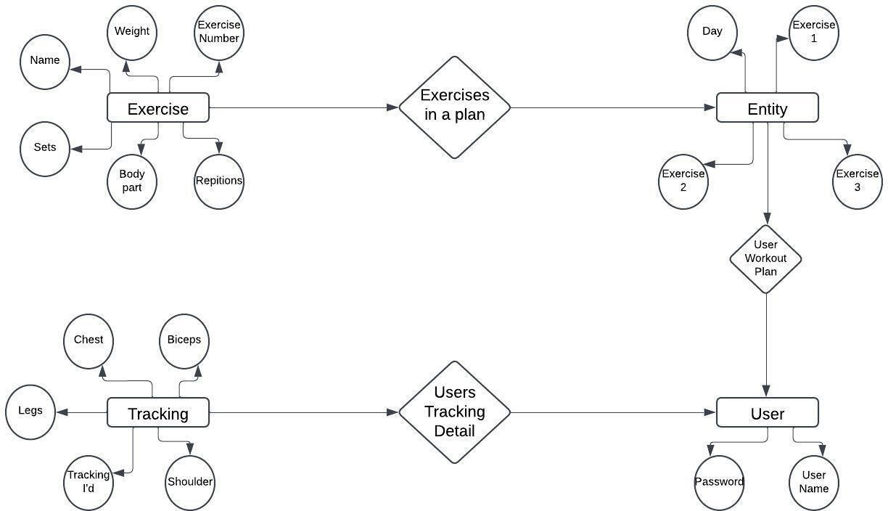

Fig 5.1 ER Diagram

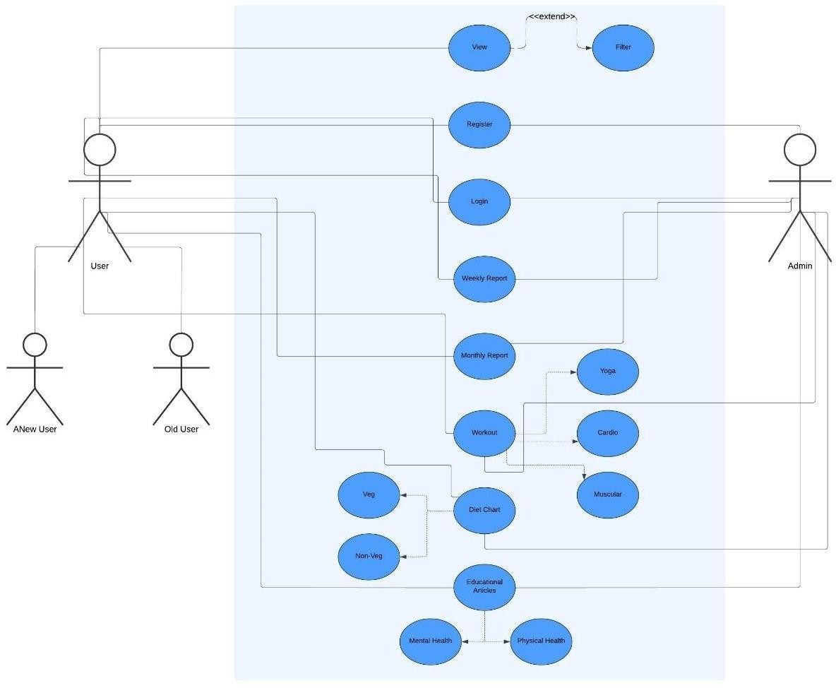

Fig 5.2 Use Case Diagram

# CHAPTER - 6 PROJECT OUTCOME

The "FitSphere" project aims to deliver a comprehensive, user-friendly platform that effectively addresses the fitness and wellness needs of a diverse user base. The anticipated outcomes of the project are as follows:

## Enhanced User Access to Health Resources

* + A platform that provides users with easily accessible fitness tools, diet plans, and wellness guides.
  + Integration of features such as BMI calculators, workout routines, and intermittent fasting guides tailored to individual needs.

## Improved Health Awareness and Lifestyle

* + Users gain insights into their health through BMI tracking and customized recommendations.
  + Promotion of sustainable health habits, including balanced diets, yoga, and regular exercise, leading to improved physical and mental well-being.

## User Engagement and Community Building

* + Creation of an interactive environment where users can share progress, seek motivation, and participate in challenges.
  + A supportive community that encourages accountability and fosters long-term commitment to health goals.

## Practical and Scalable Platform Design

* + Development of a responsive website accessible on smartphones, tablets, and PCs.
  + Scalability to integrate additional features and enhancements based on user feedback and emerging health trends.

## Simplified Approach to Fitness and Nutrition

* + A structured, research-based methodology that simplifies complex fitness and dietary practices for everyday users.
  + Empowerment of users to adopt intermittent fasting and yoga practices with easy- to-follow guides.

## Positive Impact on Physical and Mental Health

* + Users experience tangible improvements in fitness, weight management, and mental clarity.
  + FitSphere becomes a catalyst for healthier, more balanced lifestyles among its user base.

## Potential for Expansion and Collaboration

* + A foundation for partnerships with fitness experts, nutritionists, and wellness brands to further enhance the platform’s value.
  + Scope for integrating wearable technology and advanced analytics in future iterations.

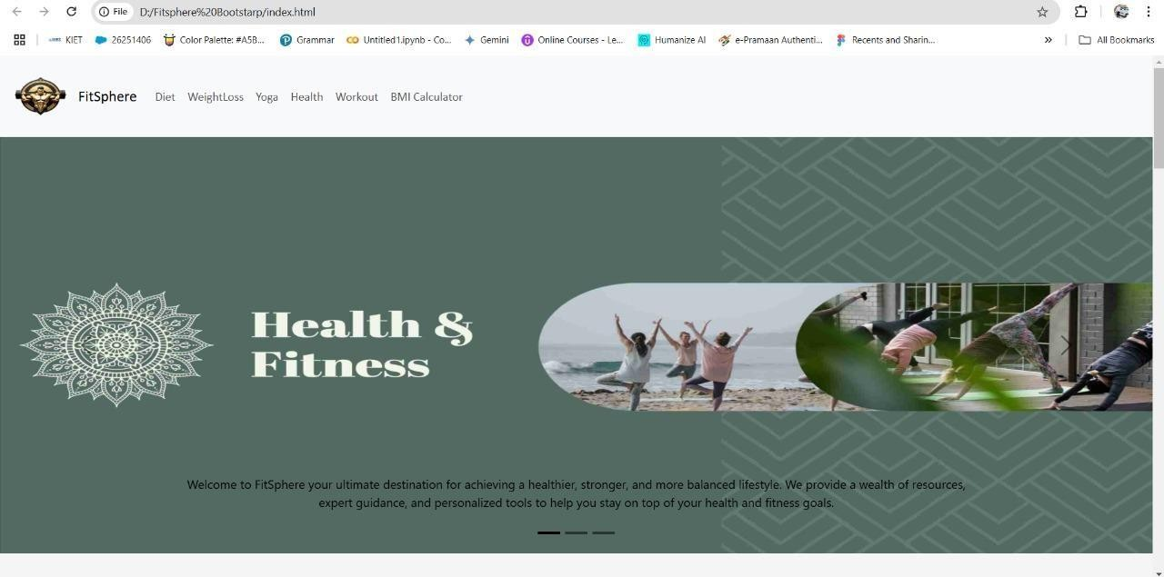

Fig 6.1 Home Page

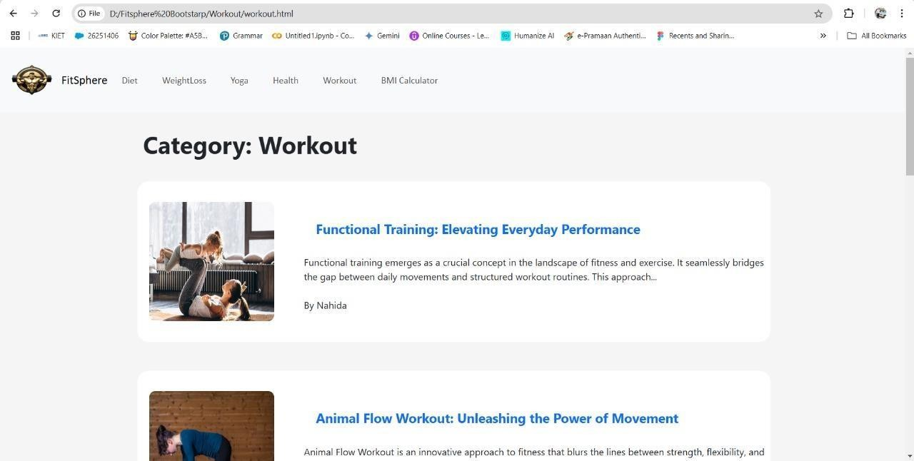

Fig 6.2 Workout Category

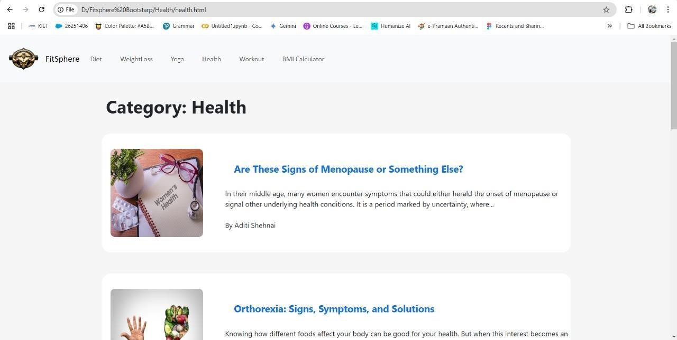

Fig 6.3 Health Category

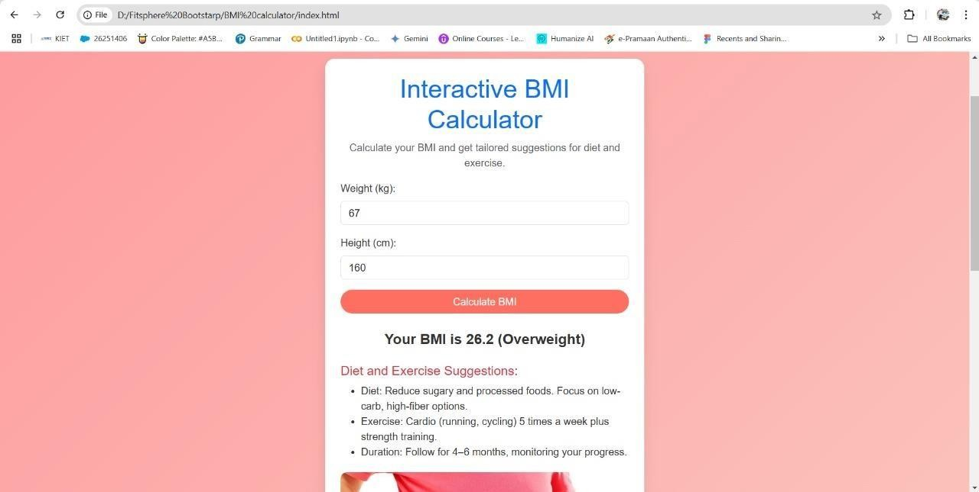

Fig 6.4 BMI Calculator

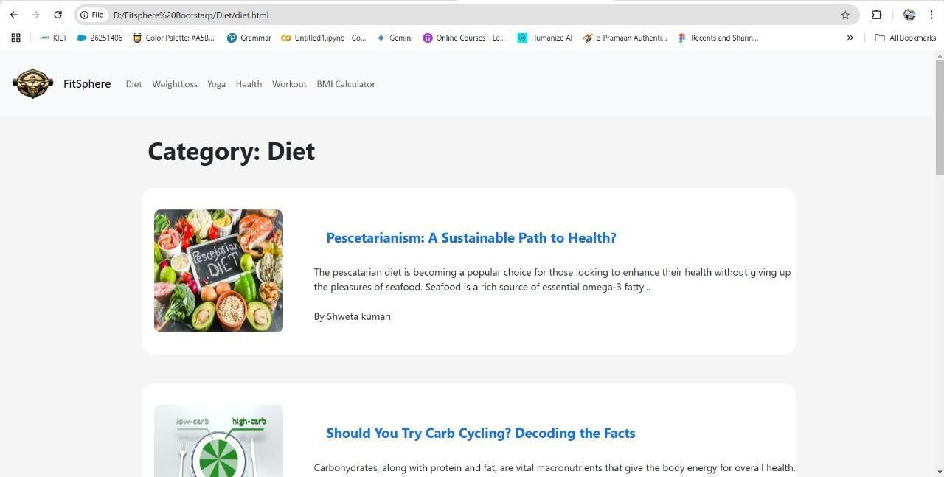

Fig 6.5 Diet Category

# REFERENCES/ BIBLIOGRAPHY

1. Fung, J., “Intermittent Fasting: Benefits and Practical Guidelines,” *Nature Reviews Endocrinology*, 2021.
2. Smith, K., “The Role of BMI in Personalized Health Planning,” *Digital Health Journal*, 2020.
3. Gupta, A., “Community Building in Fitness Apps: Impact on Long-term User Engagement,” *Journal of Social Science & Medicine*, 2019.
4. Miller, T., and Jacobs, R., “Yoga and Mental Well-being: A Comprehensive Review,”

*Frontiers in Psychology*, 2020.

1. HealthifyMe Team, “Height Weight Chart – Ideal Weight for Men and Women,” [HealthifyMe Blog,](https://www.healthifyme.com/) 2023.
2. HealthifyMe Team, “The Ultimate 7-Day Meal Plan for Intermittent Fasting,” [HealthifyMe](https://www.healthifyme.com/) [Blog,](https://www.healthifyme.com/) 2023.
3. Dube, P., “Mosambi Juice for Weight Loss? Try it Today!” [HealthifyMe Blog,](https://www.healthifyme.com/) 2023.
4. Shenai, A., “Is Poha Good For Weight Loss? Let’s Find Out,” [HealthifyMe Blog,](https://www.healthifyme.com/) 2023.
5. Bootstrap Documentation, “Building Responsive Websites with Bootstrap,” [Bootstrap](https://getbootstrap.com/) [Official Website,](https://getbootstrap.com/) 2024.
6. W3Schools, “HTML, CSS, and JavaScript Tutorials,” [W3Schools,](https://www.w3schools.com/) 2024.